**Display Journey Dashboard**

**An Effective 8-Step Process for Creating Dashboards**

The key to creating an effective advanced dashboard is rooted in the methodology of the process. Approach the dashboard creation process systematically, performing each of the following steps, and the result will be a dashboard that will help you steer your business to success.

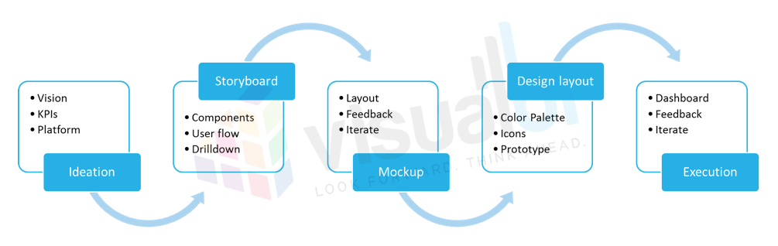

**Step 1: Requirements Gathering**

Creating a dashboard is just like any other type of journey: You really need to know where you’re going so that you can decide how to get there.

In dashboard-designing terms, that means gathering some input from the intended user(s). Important information to be gathered may include any or all of the following:

* The intended user base – CEO, Executive, Manager, Analyst, Consultant
* What platform is the dashboard going to be deployed in (Desktop, Tablet, Mobile)
* Key Performance Measures
* Level of drilldown in the measures
* The first view of the dashboard
* Filters to be applied
* Different subdivisions (Pages/tabs)
* Dashboard data sources
* Deadline for the first version and for the final version of the dashboard

**Step 2: Ideation and Wireframing**

Now that you know what your users want, it’s time for your team (project manager, backend people, front-end people) to do some brainstorming. The goal will be to determine how to accomplish the task at hand: creating a dashboard that lives up to user needs and expectations.

It’s important to assure that the entire team is on the same page, and working to accomplish the same goal. It’s also important to use tools like wireframes to create a documented path to the goal.

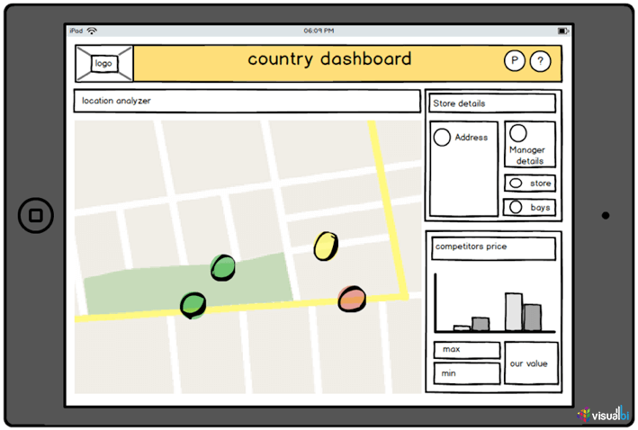

This step in the design process should answer the following questions:

* What key measures are important?
* Which components (charts, tables, KPI tiles, geo) are needed to represent the particular data?
* What filters need to be applied?
* How many tabs/pages will be required to show the different subdivisions?
* How to generate the data in the backend?
* What prompts are required?
* What action icons might the users need?
* Which team members will fill the following roles?
  + Scrum master (project manager)
  + Data collection
  + Loading the data (HANA, BW, Universe)
  + Front-end development and design (Design Studio)

**Step 3: Storyboarding**

How will the dashboard do its job? How – in a literal sense – will the dashboard complete the tasks that users ask of it?

The storyboarding phase should provide answers to specific design questions such as:

* What functions are performed after each click the user makes on the dashboard?
* If there is a drilldown, what are the levels of drilldown that will be available?
* When the user selects a filter, which components will be filtered?
* What actions do the icons perform?
* How does drilldown on one component affect other components?
* Do the chosen components satisfy the needs we need to fulfil by using them?
* How many queries do we need and which query is associated to which component?

**Step 4: Mockups and Design Layout**

This is where the dashboard truly begins to come to life. In this step you’ll decide the layout of your dashboard, and create a visual mockup.

Tools commonly used during this phase include whiteboards, Powerpoint, MS Paint, Balsamiq, Adobe Photoshop, Illustrator – even old-school pencil and paper. The choice of tool used in creating the mockup is less important than the team’s experience and comfort-level with the tool.

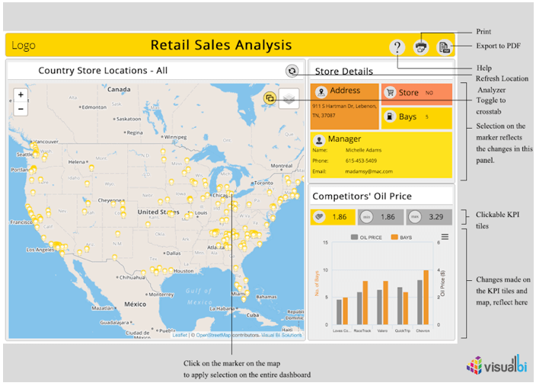

Any or all of the following will serve as inputs for shaping the layout of your dashboard:

* The placement of components
* The placement of filters
* The placement of panels and grid layouts
* The color palette of the dashboard
  + Primary color (color of the client company, perhaps?)
  + Secondary color
  + Text color
  + Background color
  + Panel or component color
* Any required animations (panel slide, zoom, pop-up box)
* Determining the filters to be shown or hidden
* Design of the icons and logo if necessary

All decisions made in previous wireframing and storyboarding steps will be incorporated in the design layout. Then a demo of the dashboard will be created – a clickable prototype – using tools such as Powerpoint and Balsamiq.

Finally, feedback about the demo mockup should be solicited from team members and from users.

**Step 5: SAP Customizations**

Taking full advantage of SAP® BusinessObjects Design Studio™ for dashboard development will require a few additional chores, such as:

* Placement of components such as grid layout, responsive layout, panels, components, text, title, header, filters, icons, and the logo on the dashboard
* Writing a CSS file that will work with the design layout of the dashboard
* Attaching data sources to components
* Tweaking performance as needed

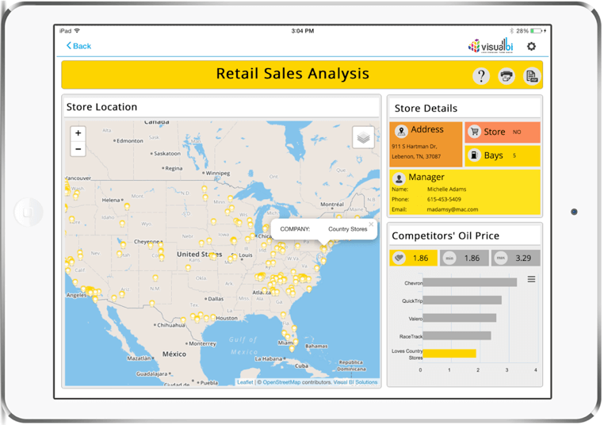

Also, using SAP® BusinessObjects Design Studio™ **Visual BI Extensions**helps create innovative charts and tables. This gives the users more functionality and varied vision of viewing their data. It makes us push the boundaries and showcase the data in a more granulated and easy-to-understand way.

**Step 6: Solicit Feedback**

Now the bulk of our dashboard design work is done. But does it meet with the approval of our users? This is the time to find out by soliciting feedback.

Certainly it’s important to gather feedback from users (or user representatives). But don’t forget to also solicit feedback from all team members. Some team members may have been working in relative isolation on individual components of the project. This is a great opportunity to solicit their first-impression feedback on the dashboard in its nearly complete state.

**Step 7: Iterate As Needed**

This step may be very short, or it may be interminably long. It all depends upon the quality and thoroughness with which steps 1 through 5 have been completed.

If few complaints or suggestions result from the previous step of soliciting feedback, this step will be short and sweet. Otherwise, multiple iterations of soliciting feedback and implementing the resulting changes or fixes may be required.

This stage often presents an optimal opportunity to evaluate whether parallel processing is needed to improve performance.

**Step 8: Create Documentation**

The final step is to create supporting documentation for your dashboard. Two separate forms of documentation are typically created:

1. Documentation for the users, providing instruction for utilizing the dashboard in meeting their needs
2. Internal documentation detailing the developmental process for future reference by employees – essentially a textual narrative of steps 1 through 7 of the dashboard development process